**Sensor Impact Evaluation and Verification Framework for Fault Detection and Diagnostics: Implementation on Flexible Research Platform**

Liang Zhang, Matt Leach

National Renewable Energy Laboratory

*Section 1 - Introduction and Section 2 - Developed Framework were included in the Q3 report but modified in the Q4 report. The work completed in Q4 is detailed in Section 3 and Section 4.*

# 1. Introduction

Equipment faults and control errors are pervasive in today’s commercial buildings [1]. Building faults waste a substantial amount of energy each year— 0.3 to 1.8 quadrillion BTU of primary energy in the United States [2], or 5% to 15% of energy used in the commercial buildings sector [3]. Fault detection and diagnosis (FDD) senses operational faults (fault detection) and identifies their root causes (fault diagnosis). Automated fault detection and diagnosis (AFDD) performs FDD automatically with minimal human intervention. Properly implemented, AFDD enables building operators to simultaneously improve comfort and reduce energy use, closing the gap between actual and optimal building performance [4].

With decreasing hardware costs and increasing data accessibility, massive datasets are collected from sensors and meters. The increasing data empower data-driven FDD; as a result, data-driven FDD methods have been broadly applied. Since FDD methods are largely data-driven, sensors, which are the foundation and source of data, are increasingly studied in FDD research. According to the conclusions of a previous literature review *(“Literature Review of Sensor Topics in FDD Use Cases”*), sensor faults (33 papers were found, accounting for 37% of reviewed technical papers) and sensor selection (14 papers were found, accounting for 16% of reviewed technical papers) are the most widely studied topics. This indicates that the selection of sensors and accuracy of those sensors are the most important sensor-related factors for FDD applications. Sensor selection is critical to early-stage sensor design and final-stage model improvement in FDD applications, while sensor accuracy is important during the operational stage of FDD.

Although there are many studies on sensor selection and sensor accuracy, there is a lack of studies that systematically quantify sensor impact on FDD performance or overall building performance. Quantified sensor impact can better guide sensor design for FDD applications. As a result, a framework to evaluate sensor impact on FDD performance, and to further evaluate the impact of FDD performance on building performance, such as energy efficiency and thermal comfort, is greatly needed. With such a framework, the sensor configurations of FDD applications can be directly evaluated in terms of building energy efficiency and thermal comfort, guiding more purposeful design (and evolution) of FDD sensors.

To address this need, we have developed a systematic and generic framework for sensor impact evaluation and verification. The developed framework is based on physics-based (EnergyPlus) faulty building models and a data-driven machine-learning based FDD algorithm. The use of EnergyPlus enables an exhaustive set of sensors to be evaluated; high-performance data-driven modeling can be used in combination to quickly and automatically build FDD models and then evaluate the impact of that sensor set on FDD performance without the need for domain knowledge regarding rule-based or physics-based FDD modeling methods.

With the framework developed, practical conclusions and suggestions regarding sensors can be made for building FDD development. The framework provides guidelines for different building types, HVAC system types, fault types and sensor types on how to select sensors for FDD, how accurate the sensors need to be, and what impact they have on building energy efficiency and thermal comfort. Section 2 describes the framework in detail. Section 3 introduces the application of the developed framework for Oak Ridge National Laboratory’s two-story Flexible Research Platform (FRP). Detailed conclusions related to the impact of sensor selection and sensor accuracy are drawn; FDD model performance evaluation and building performance metrics are summarized and calculated. In Section 4, we summarize the work completed in FY20 Q3 and Q4, and plan future work in FY21.

# 2. Developed Framework

The developed framework consists of three domains and two evaluation modules that connect them. The three domains are:

* Domain 1: Sensor Configuration
* Domain 2: FDD Model Performance
* Domain 3: Building Performance

And the two evaluation modules that connect the three domains to realize the evaluation of sensor impact are:

* Evaluation Module 1: Quantification of Sensor Selection and Sensor Accuracy Impact on FDD Model Performance
* Evaluation Module 2: Quantification of FDD Model Performance Impact on Energy Efficiency and Thermal Comfort.

A diagram of the three domains and two evaluation modules is shown in Figure 1. Domain 1 (Sensor Configuration) consists of two major sensor topics according to previous literature review, which are sensor accuracy and sensor selection. Domain 1 defines the boundary of sensor topics in this framework, which focus on sensor selection, sensor accuracy and their impacts. Domain 1 further defines the candidate sensors for evaluation. The most direct impact of sensor configuration is to improve FDD model performance. Domain 2 (FDD Model Performance) defines the source of building data, FDD algorithms, and fault types to be considered. Evaluation Module 1 connects Domain 1 and Domain 2 by quantifying the impact of sensor configuration on FDD model performance. Domain 3 (Building Performance) defines the ultimate quantities of interest. In this framework, Domain 3 consists of four parts: (1) building energy efficiency, (2) thermal comfort, and (3) sensor and maintenance cost. Evaluation Module 2 connects Domain 2 and Domain 3 by quantifying the impact of FDD model performance on building performance. This framework starts with sensor configuration and ends with its impact on building performance, providing conclusions and guidelines for FDD applications from a sensor perspective. In the following subsections, each domain and evaluation module are introduced in detail.

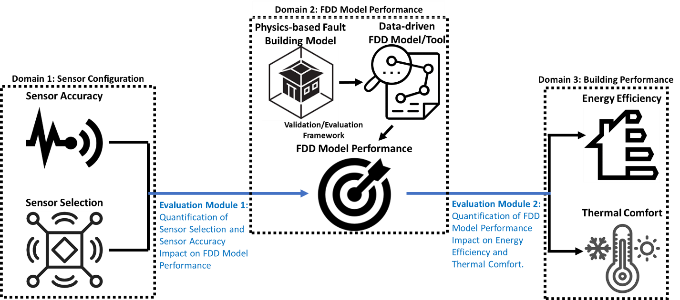

Figure 1. Diagram of the developed framework

## 2.1. Domain 1: Sensor Configuration

The previous literature review indicated that sensor selection and sensor accuracy are the most important topics in FDD sensor related studies. According to this conclusion, sensor configuration (Domain 1) consists of two elements: (a) sensor selection and (b) sensor accuracy.

Within this framework sensor selection has two aspects. First, there is a set of sensors that are critical to FDD model performance; it is important to identify this set of sensors and specify it as part of the building sensor design (or add sensors as needed to an existing sensor design). Second, it is beneficial to identify extraneous sensors and eliminate them from the FDD dataset; this improves the performance of the FDD model. The concept of sensor selection in this framework includes both aspects, which can be used either in early-stage sensor design or late-stage sensor modification. We have some initial conclusions on sensor selection from NREL’ previous FDD study, which evaluated FDD model performance for different sensor sets (categorized as basic, moderate, and rich, based on the number of sensor types included). Results from that study show that sensor selection has a large impact on FDD performance. In this framework, sensors are not considered as sets, but are evaluated more generally; the framework focuses on how to select sensor sets for different building types, HVAC systems, and fault types, and how to quantify the impact of sensor selection.

Sensor inaccuracy can be divided into four types: bias, drifting, precision degradation and complete failure [5]. In NREL’s previous FDD study, sensor bias was introduced to thermostat measurement and economizer sensors, and deterioration of building energy performance was observed. In this framework, sensor inaccuracy is extended to more types (drift, precision degradation and complete failure), and impact on both FDD performance and overall building performance is evaluated.

Domain 1 is the starting point of the framework, defining candidate sensors and potential sensor inaccuracy and uncertainty. It sets the boundaries of the sensor-related settings that shape the resulting impact evaluation.

## 2.2. Domain 2: FDD Model Performance

Domain 2 (FDD Model Performance) defines the settings of (1) building and building model, (2) building data, (3) FDD algorithm, and (4) FDD performance metrics.

The proposed framework is based on physics-based EnergyPlus models (a reference building model as well as a set of fault models), data generated from these models, and a data-driven machine-learning based FDD algorithm. EnergyPlus enables an exhaustive set of (virtual) sensors to be considered; the data-driven model can quickly evaluate their impact on FDD performance without the need for extensive FDD domain knowledge.

The example building model in this framework is a calibrated EnergyPlus [6, 7] model of Oak Ridge National Laboratory’s two-story Flexible Research Platform (FRP) [8, 9]. The FRP is a small-sized (3,200 ft2) commercial building that has a single packaged rooftop unit (RTU) connected to a multi-zone variable air volume (VAV) system. The FRP is designed to imitate the construction and operation of a 1980’s era small office building typical of the southeastern United States. The RTU is a 12.5-ton unit which includes a natural gas furnace; the connected VAV system serves a total of 10 zones (8 perimeter and 2 core) with electric resistance reheat. Figure 2 shows the actual facility alongside a rendering of the virtual testbed.

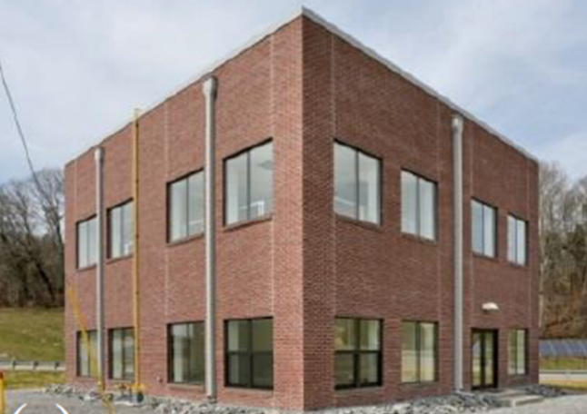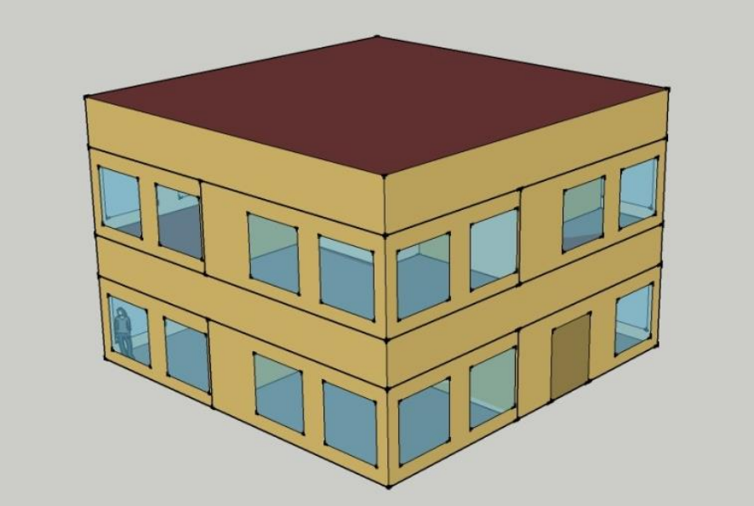

Figure . Virtual testbed modeled by EnergyPlus (right), calibrated to Oak Ridge National Laboratory’s Flexible Research Platform (left, Source: [10])

The fault model library applied to the reference model covers 26 fault types over a range of different fault intensities, as shown in Table 1. The building data used to demonstrate this framework are generated from these EnergyPlus Models.

## 2.3. Domain 3: Building Performance

The key metrics for building performance are building energy efficiency, thermal comfort, and cost. Buildings consumed 40% of all US energy in 2010; appropriately, energy efficiency is considered the most important evaluation metric for this project. Thermal comfort is also important. In cases where building HVAC system(s) fail, it is possible for energy consumption to decrease at the expense of thermal comfort (e.g., inability to meet cooling load). In general, this tradeoff between thermal comfort and energy consumption is quite common in the context of buildings. The third metric for building performance is cost, including both sensor costs and building maintenance costs. Sensor costs are a key factor in sensor selection. From an FDD performance perspective, more sensors would always be better; however, it is expensive to install and maintain sensors, so a balance needs to be achieved between cost and performance.

Table 1. Fault types and intensities considered

|  |  |  |  |
| --- | --- | --- | --- |
| **No.** | **Fault type** | **Fault intensity definition** | **Fault intensity** |
| 1 | Condenser fan degradation | reduction in motor efficiency as a fraction of the non-faulted motor efficiency | 0.1, 0.167, 0.233, 0.3 |
| 2 | Condenser fouling | ratio of reduction in condenser coil airflow at full load | 0.1, 0.233, 0.367, 0.5 |
| 3 | Nonstandard refrigerant charging: overcharge | ratio of charge deviation from the normal charge level | 0.0375, 0.075, 0.1125, 0.15 |
| 4 | Nonstandard refrigerant charging: undercharge | ratio of charge deviation from the normal charge level | -0.3, -0.225, -0.15, -0.075 |
| 5 | Presence of non-condensable in refrigerant | ratio of the mass of non-condensable in the refrigerant circuit to the mass of non-condensable that the refrigerant circuit can hold at standard atmospheric pressure | 0.1, 0.267, 0.433, 0.6 |
| 6 | Refrigerant liquid-line restriction | ratio of increase in the pressure difference between the condenser outlet and evaporator inlet due to the restriction | 0.1, 0.167, 0.233, 0.3 |
| 7 | Thermostat measurement bias | thermostat measurement bias in K | -3, -1, 1, 3 |
| 8 | Improper time delay setting in occupancy sensors | delayed time setting in hours | 0.25, 0.5, 0.75, |
| 9 | Lighting setback error: delayed onset | delay in the onset of overnight lighting setback in hours | 1, 2, 3, |
| 10 | Lighting setback error: early termination | early termination of overnight lighting setback in hours | 1, 2, 3, |
| 11 | Lighting setback error: no overnight setback | absence of overnight lighting setback | All days, Weekdays only, Weekend only, |
| 12 | Oversized equipment at design | ratio of increased sizing compared to the correct sizing | 0.1, 0.233, 0.367, 0.5 |
| 13 | HVAC setback error: delayed onset | delay in onset of overnight HVAC setback in hours | 1, 1.667, 2.333, 3 |
| 14 | HVAC setback error: early termination | early termination of overnight HVAC setback in hours | 1, 1.667, 2.333, 3 |
| 15 | HVAC setback error: no overnight setback | absence of overnight HVAC setback | All days, Weekdays only, Weekend only, |
| 16 | Excessive infiltration around the building envelope | ratio of excessive infiltration around the building envelope compared to the non-faulted condition | 0.1, 0.2, 0.3, 0.4 |
| 17 | Economizer opening stuck at certain position | ratio of economizer damper at the stuck position | 0, 0.333, 0.666, 0.1 |
| 18 | Return air duct leakages | unconditioned air introduced to return air stream at full load condition as a ratio of the total return airflow rate | 0.1, 0.167, 0.233, 0.3 |
| 19 | Supply air duct leakages | ratio of the leakage flow relative to supply flow | 0.1, 0.167, 0.233, 0.3 |
| 20 | Air handling unit fan motor degradation | ratio of fan motor efficiency degradation | 0.1, 0.167, 0.233, 0.3 |
| 21 | Duct fouling | reduction in evaporator coil airflow at full load condition as a ratio of the design airflow rate | 0.1, 0.2, 0.3, 0.4 |
| 22 | Biased economizer sensor: mixed temperature | biased temperature level in K | -3, -1, 1, 3 |
| 23 | Biased economizer sensor: outdoor RH | biased RH level in % | -10, -5, 5, 10 |
| 24 | Biased economizer sensor: outdoor temperature | biased temperature level in K | -3, -1, 1, 3 |
| 25 | Biased economizer sensor: return RH | biased RH level in % | -10, -5, 5, 10 |
| 26 | Biased economizer sensor: return temperature | biased temperature level in K | -3, -1, 1, 3 |

## 2.4. Evaluation Module 1: Sensor Impact on FDD Performance

Although many papers identified through literature review indicate that sensor selection and sensor accuracy have significant impact on FDD performance, a lack of standardization in quantification makes it difficult to draw comprehensive conclusions. This evaluation module is designed to comprehensively analyze sensor selection, sensor accuracy, and the interactions between them. Conclusions regarding sensor selection and sensor accuracy will be based on a range of fault types and HVAC systems. For each sensor type analyzed via this framework, the impact of sensor accuracy will be evaluated, and the corresponding uncertainty will be quantified. The framework is designed to determine what sensors are critical to FDD performance and how accurate those sensors should be to keep FDD error low. It is also important to note that sensor selection and sensor accuracy are not independent from each other; the interaction between them is important. The framework enables us to capture this interaction by incorporating sensor accuracy uncertainty into the sensor selection process.

## 2.5. Evaluation Module 2: FDD Performance Impact on Building Performance

Evaluation Module 2 quantifies the impact of improved (or degraded) FDD performance on building performance. The impact will be evaluated for different fault types. A comprehensive metric in Domain 3 will be specified to quantify the net value of energy efficiency, thermal comfort, and cost. Evaluation Module 2 also evaluates the impact of false negative (faults not detected) and false positive (false alarm) cases separately. False negatives directly impact energy efficiency and thermal comfort. False positives only affect maintenance costs (but also degrade confidence in FDD alerts).

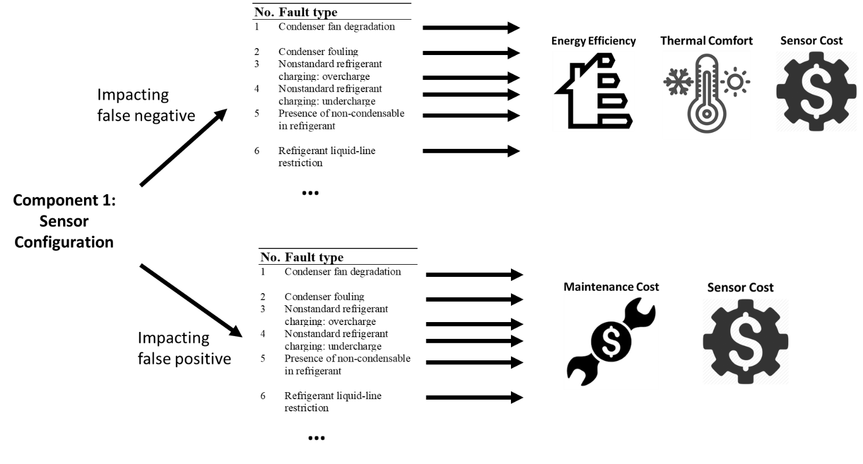

Figure 3. Evaluating the impact of false negative and false positive cases.

# 3. Case Study: Initial Implementation of Framework on FRP

To demonstrate the application of the developed framework, we implemented the conceptual framework for a real-building case—FRP—with detailed settings, procedures, and quantitative analysis documented in this section. This demo case can help better demonstrate the logic, procedures, outcomes, and significance of the developed framework. This section is organized as follows: Section 3.1 covers sensor configuration, Section 3.2 covers FDD model performance, and Section 3.3 covers building performance, aligning with the structure in the developed framework in Section 2.

## 3.1. Specifications on Domain 1: Sensor Configuration

As mentioned in Section 2.1, sensor configuration (Domain 1) consists of two elements: (a) sensor selection and (b) sensor accuracy. In this subsection, the specification of sensor selection and sensor accuracy are quantitively defined. It is worth mentioning that sensor selection and sensor accuracy have been studied independently (without interaction with each other); part of our plan for FY21 is to study the interaction between them.

### 3.1.1. Sensor Selection

To comprehensively study and quantify the sensor selection procedure and the impact of sensor selection on FDD performance, a feature (sensor) extraction and selection method for whole-building FDD is developed and applied to the FRP, and FDD performance with well selected sensors is compared to that for common selected sensor. The method is first introduced in Section 3.1.1.1, and the method application for the FRP is introduced in Section 3.1.1.2.

#### 3.1.1.1. Feature/Sensor Extraction and Selection Method for Whole-Building FDD

Sensor selection process is also termed as feature selection (and sometimes termed as feature engineering) in data-driven modeling. A method is developed to guide feature engineering for data-driven whole-building FDD algorithms. The method focuses on the integration of feature selection with feature extraction, thus providing a complete workflow for generating an optimal feature set. The method starts with raw sensor data available from energy meters, a building automation system (if present), weather stations, or similar sources. The logic of the method is to aggressively extract information from these sensor data, even if huge numbers of features are produced. Subsequently, the method uses feature selection techniques to reduce the feature space to an optimal feature set with the highest generalization (or cross-validation accuracy). The full details of this sensor/feature selection method can be found in our paper (A Systematic Feature Extraction and Selection Framework for Data-Driven Whole-Building Automated Fault Detection and Diagnostics in Commercial Buildings), which has already been accepted by Building and Environment.

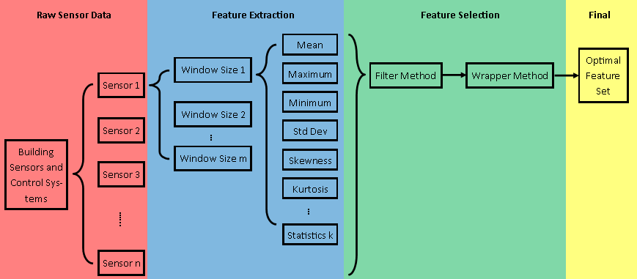

Figure 4. Diagram of feature extraction and feature selection method for whole-building FDD.

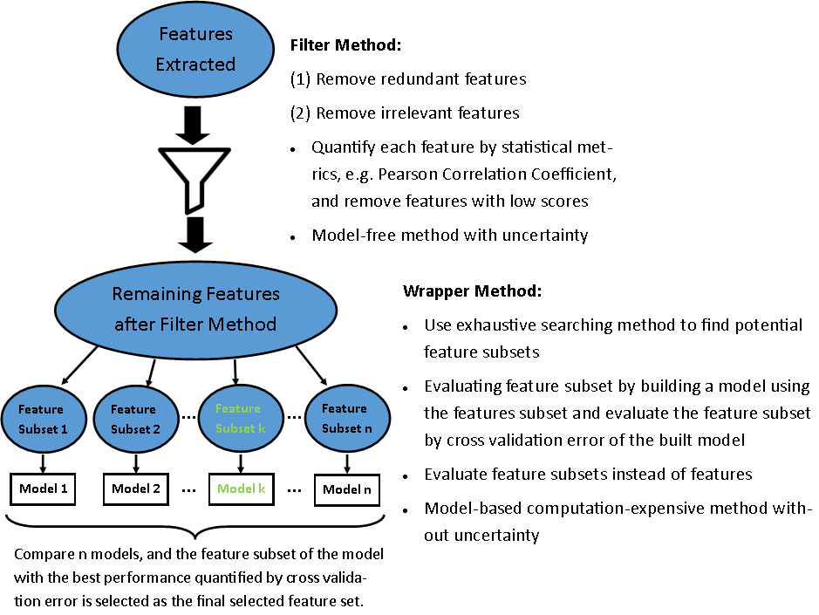

Figure 5. Diagram of the feature selection module in the developed method

#### 3.1.1.2. Results and Discussions

This section analyzes the most important features selected for each fault type for the FRP, which can provide understanding of the symptoms and characteristics of specific faults. Table 2 shows the top 3 features for each fault type.

Among four lighting-related faults (delayed onset, early termination, no overnight setback, and improper time delay setting in occupancy sensor), the selected features include lighting electricity and total building electricity consumption. The lighting setback faults affect lighting electricity and total building electricity consumptions directly due to improper control of the lighting setback schedule, while the improper time delay setting in occupancy sensors indirectly affects the lighting schedule via controls coupled to the occupancy sensor installed in the thermal zone. Thus, the selection of prioritized sensors is intuitive.

Among the three HVAC setback faults (delayed onset, early termination, and no overnight setback), the total HVAC electricity consumption, total building electricity consumption, and supply air temperature to a certain room are selected as critical sensors. The change in setback schedule in the HVAC system directly affects the energy consumption of the heating and cooling equipment in the RTU as well as VAV box reheat coils that control room temperatures. To be more specific, for the HVAC setback delayed onset, the most important feature is the last few hours of the total HVAC electricity consumption, while for the early termination, the most important feature is the first few hours of supply air temperature data for room 106. For the early termination fault, the supply air temperature is affected by the earlier start of the room conditioning, which enables the VAV box to maintain the room temperature setpoint defined for the occupied period. The selection of room 106 can be interpreted as follows: it is the room with the highest thermal mass that required the supply air temperature to change significantly to meet the room temperature setpoint.

Table 2. Top three extracted and selected features for each fault type

|  |  |  |  |
| --- | --- | --- | --- |
| **AHU fan motor degradation** | | **Improper time delay setting in occupancy sensors** | |
| 1 | rooftop supply fan outlet system node temperature [°C]_12h_mean_2/2 | 1 | interior lights electricity [W]_12h_std_1/2 |
| 2 | rooftop mixed air outlet system node temperature [°C]_24h_min_1/1 | 2 | interior lights electricity [W]_3h_mean_6/8 |
| 3 | rooftop mixed air outlet system node temperature [°C]_2h_mean_4/12 | 3 | interior lights electricity [W]_6h_mean_3/4 |
| **Biased economizer sensor: mixed temperature** | | **Lighting setback error: delayed onset** | |
| 1 | rooftop mixed air outlet system node temperature [°C]_3h_min_4/8 | 1 | interior lights electricity [W]_12h_skew_1/2 |
| 2 | rooftop mixed air outlet system node temperature [°C]_3h_max_3/8 | 2 | electricity facility [W]_3h_mean_8/8 |
| 3 | rooftop mixed air outlet system node temperature [°C]_24h_min_1/1 | 3 | electricity facility [W]_1h_mean_13/24 |
| **Duct fouling** | | **Lighting setback error: early termination** | |
| 1 | rooftop heating coil outlet system node temperature [°C]_6h_max_2/4 | 1 | interior lights electricity [W]_2h_mean_4/12 |
| 2 | rooftop supply fan outlet system node temperature [°C]_6h_mean_2/4 | 2 | electricity facility [W]_3h_min_3/8 |
| 3 | rooftop heating coil outlet system node temperature [°C]_3h_mean_3/8 | 3 | electricity facility [W]_1h_mean_9/24 |
| **Economizer outdoor air damper stuck** | | **Lighting setback error: no overnight setback** | |
| 1 | rooftop mixed air outlet system node temperature [°C]_6h_std_4/4 | 1 | interior lights electricity [W]_3h_mean_8/8 |
| 2 | rooftop mixed air outlet system node temperature [°C]_3h_std_8/8 | 2 | interior lights electricity [W]_24h_min_1/1 |
| 3 | rooftop mixed air outlet system node temperature [°C]_1h_mean_14/24 | 3 | interior lights electricity [W]_1h_mean_22/24 |
| **HVAC setback error: delayed onset** | | **Return air duct leakages** | |
| 1 | whole-building facility total HVAC electric demand power [W]_1h_mean_23/24 | 1 | rooftop mixed air outlet system node temperature [°C]_12h_skew_2/2 |
| 2 | room 102 supply inlet system node temperature [°C]_2h_std_12/12 | 2 | rooftop cooling coil outlet system node temperature_[°C]_12h_skew_2/2 |
| 3 | electricity facility [W]_2h_std_12/12 | 3 | rooftop mixed air outlet system node temperature [°C]_1h_mean_16/24 |
| **HVAC setback error: early termination** | | **Supply air duct leakages** | |
| 1 | room 106 supply inlet system node temperature [°C]_6h_std_1/4 | 1 | room 106 supply inlet system node temperature [°C]_12h_mean_2/2 |
| 2 | whole-building facility total HVAC electric demand power [W]_6h_std_1/4 | 2 | room 205 zone mean air temperature [°C]_1h_mean_7/24 |
| 3 | room 102 supply inlet system node temperature [°C]_6h_std_1/4 | 3 | electricity facility [W]_1h_mean_7/24 |
| **HVAC setback error: no overnight setback** | | **Thermostat bias** | |
| 1 | electricity facility [W]_1h_mean_2/24 | 1 | heating electricity [W]_12h_std_1/2 |
| 2 | whole building facility total HVAC electric demand power [W]_1h_mean_3/24 | 2 | heating electricity [W]_2h_mean_4/12 |
| 3 | whole building facility total HVAC electric demand power [W]_6h_mean_1/4 | 3 | heating electricity [W]_1h_mean_7/24 |

The heating coil air outlet and supply fan outlet temperatures are selected as critical sensors for the duct fouling fault. Duct fouling is defined as dust accumulation within the duct system that increases flow resistance in the air system and pressure drop across the supply fan. The increased pressure drop in the supply fan then results in increased fan energy consumption and additional heat gain to the air stream compared to the same air volume in the un-faulted case. One extra feature in the virtual testbed model is that the heat gain from the fan has an impact on the setpoints of the economizer, cooling coil, and heating coil in the RTU. The model predicts the temperature increase caused by the heat gain and subtracts it from the original temperature setpoints, thus mitigating the temperature increase across the fan. While the virtual testbed model has the capability of optimizing the supply air temperature at the system level, RTUs in the field mostly use predefined setpoints and packaged proportional–integral–derivative (PID) controllers. Internal device controls (outdoor air damper, coil valve, electric output, etc.) match the local temperature measurement to the setpoint. Although there is a common practice where the engineer sets the setpoint temperature a few degrees below the required supply air temperature setpoint to prepare for the heat gain in the air system, typical field controllers are nevertheless less sophisticated than the virtual testbed model used in this study. These setpoints are, however, affected differently by the fault during different seasons. While the economizer mixed air temperature setpoint is only affected when economizing is feasible, the cooling coil and heating coil setpoints are affected when either cooling or heating demand is present. Preliminary virtual testbed simulation results indicated that heating demand is dominant compared to economizing and cooling. Thus, the selection of the heating coil air outlet temperature as the major sensor is intuitive.

The sensors installed within the RTU are also critical for detecting faults such as AHU fan motor degradation, biased economizer sensor (mixed temperature), stuck outdoor air damper, and return air duct leakages. The temperature sensors located at the outlet of the fan and mixed air chamber were prioritized for the AHU fan motor degradation fault. The AHU fan motor degradation fault results in a decrease in fan total efficiency. Because the fan causes heat gain to the air stream when it is installed within the air stream, inefficient operation of the fan increases the heat gain to the supply air stream, which increases the supply fan outlet air temperature. In the FRP EnergyPlus model, the mixed air temperature is controlled by the economizer (with differential enthalpy economizer control) when the outdoor air condition is favorable for free cooling. As described above, the mixed air temperature setpoint is affected by the additional heat gain from the fan. The biased economizer sensor (mixed temperature) fault directly affects the setpoint of the mixed air temperature, and thus the selection of critical sensors is reasonable. Because the economizer system controls mixed air temperature via the outdoor air and return air dampers, the same set of sensors is also affected when the outdoor air damper is stuck in a certain position. The return air duct leakage is defined as the leakage within the return duct that is exposed to the ambient. The supply fan installed in the RTU draws air and maintains negative pressure in the return duct. If a leak occurs, outdoor air will be introduced into the return air stream even when it is not needed, which can again result in a change in the mixed air temperature. Changes in mixed air temperature also affect the cooling or heating load on the RTU depending on weather and operating conditions.

Heating electricity consumption was prioritized for the thermostat bias fault. This fault was simulated in the FRP EnergyPlus model by increasing and decreasing the room temperature setpoint up to 3°C. It should be noted that room temperature setpoint is not among the sensors available to the FDD algorithm, therefore this method of simulating thermostat bias does not affect algorithm performance. The thermostat measurement bias in all rooms directly affects both heating and cooling energy consumption. For example, a positively biased thermostat (equivalent to decreased room temperature setpoint) increases the cooling demand in the summer season, but it also reduces the heating demand for the winter season. The selection of heating electricity consumption as a critical sensor can be interpreted as the impact on heating energy being larger than the impact on cooling energy.

Supply air duct leakage is defined as the conditioned air from an RTU being leaked to the unconditioned spaces within the building. The leaked air does not reach the conditioned spaces in the building, but it eventually gathers in the return plenum and flows back through the return duct. There are two major behaviors caused by supply air duct leakage: (1) reduced airflow to all rooms because the leak occurs before the conditioned air reaches thermal zones, (2) and decreased or increased return air temperature during the cooling or heating season, respectively, due to the conditioned air from the RTU leaking back to the return air plenum. During the heating season, the reduced airflow to the conditioned spaces results in insufficient heating capacity and additional reheat in the VAV box to maintain comfortable room temperatures. In the cooling season, the reduced airflow results in insufficient cooling capacity for conditioning all rooms; the supply fan will therefore increase speed to meet demand. On the other hand, the reduced return air temperature provides free cooling opportunity during the cooling season and reduces the load on the cooling coil when dehumidification is required. In the shoulder season when dehumidification and VAV reheat are both required, overall energy consumption of the system is prioritized due to reduced cooling and reheating energy. Sensors such as the supply air temperature to room 106, zone temperature of room 205, and total building electricity consumption were selected as critical sensors for this fault. In the FRP EnergyPlus simulations, the reduced airflow resulted in increased VAV heating (in heating season), which can also be observed via increased supply air temperature to the thermal zone. In the cooling season, although the supply fan increased its speed to meet the cooling demand, the rated capacity of the RTU was not enough to satisfy the entire cooling demand in the building, resulting in increased room temperatures. For these reasons, the selection of critical sensors for the supply air duct leakage fault is also intuitive.

One of the advantages of the data-driven method is that it requires little domain knowledge in the modeling process but can still reflect physical knowledge in its result. The analysis in this section shows that the developed method can even provide insight into physical systems. In this case, the known mechanisms used to model the faults provide the “answer key” for which features are likely to be relevant; the analysis here checks whether the actual features selected match those known to be affected by the fault model. In other cases, users of the developed method may have neither knowledge of nor access to the underlying fault models and may have limited understanding of fault mechanisms. By checking the features selected, they could better understand the fault mechanisms at play.

It is worth mentioning that the features extracted and selected for this analysis are only applicable to this particular case study. The developed method provides a generic workflow to generate specific features for specific buildings.

To demonstrate the importance of feature extraction/selection and the effectiveness of the developed method, the model built by the developed method is compared with a baseline model built using a simple literature reported sensor selection method [4]. Feature selection is limited to the inherent feature selection performed as part of generating the random forest model. An error metric, Combined Detection and Diagnosis Rate (CDDR [11]) is used to evaluate both models. Both models use the same data source, data-driven algorithm (random forest), and parameters.

The CDDRtotal of the baseline method is 0.779, which is 9.6% lower than that for the developed method; the CDDRtotal for the test data is 0.723, which is 10.7% lower than that for the developed method. With the developed method, fewer features are selected, and higher accuracy is achieved, indicating that the developed method extracts more condensed and informative features from the original data set.

Performance of the two models is also quantified via comparison of the true positive rate (TPR) of each fault type (Table 3). The developed method achieves much higher accuracy for several fault types, including AHU fan motor degradation (TPR increases from 0.70 to 0.84), biased economizer sensor mixed temperature (from 0.48 to 0.79), duct fouling (from 0.47 to 0.82), economizer outdoor air damper stuck (from 0.70 to 0.79), HVAC setback error delayed onset (from 0.79 to 0.96), HVAC setback error early termination (from 0.90 to 0.99), and return air duct leakage (from 0.39 to 0.69). The TPRs of remaining fault types largely remain the same.

Table 3. Comparison between true positive rate of two models: (1) Model 1: developed feature extraction and selection method and (2) Model 2: simple feature extraction and selection

|  |  |  |
| --- | --- | --- |
| **Fault Types** | **TPR of Model 1** | **TPR of Model 2** |
| Air handing unit fan motor degradation | 0.84 | 0.70 |
| Biased economizer sensor mixed temperature | 0.79 | 0.48 |
| Biased economizer sensor outdoor air temperature | 0.37 | 0.03 |
| Biased economizer sensor outdoor relative humidity | 0.00 | 0.00 |
| Biased economizer sensor return relative humidity | 0.00 | 0.00 |
| Biased economizer sensor return temperature | 0.05 | 0.00 |
| Condenser fouling | 0.03 | 0.14 |
| Duct fouling | 0.82 | 0.47 |
| Economizer outdoor air damper stuck | 0.79 | 0.70 |
| Excessive infiltration | 0.00 | 0.00 |
| HVAC setback error delayed onset | 0.96 | 0.79 |
| HVAC setback error early termination | 0.99 | 0.90 |
| HVAC setback error no overnight setback | 0.95 | 0.97 |
| Improper time delay setting in occupancy sensors | 0.95 | 0.95 |
| Lighting setback error delayed onset | 0.78 | 0.83 |
| Lighting setback error early termination | 0.93 | 0.90 |
| Lighting setback error no overnight setback | 0.97 | 0.97 |
| Liquid line restriction | 0.35 | 0.34 |
| Non-standard charging | 0.06 | 0.12 |
| Oversized equipment at design | 0.00 | 0.00 |
| Presence of non-condensable | 0.00 | 0.00 |
| Return air duct leakages | 0.69 | 0.39 |
| Supply air duct leakages | 0.74 | 0.75 |
| Thermostat bias | 0.99 | 0.99 |
| None | 0.98 | 0.95 |

### 3.1.2. Sensor Accuracy

In this study, we considered, implemented, and simulated four types of common sensor faults that cause sensor inaccuracy in buildings. In terms of the type of deviations that sensors suffer from, sensor faults can be classified into (a) complete failure; (b) bias; (c) drifting; and (d) precision degradation. Complete failure represents the case where sensor output is always constant (sometimes a very large or negative number) or even has no value (“NaN”), completely failing to capture any information. Sensor bias is a small offset, constant in absolute value (e.g., +1°C) or in relative value (e.g., -5%) between the actual value and sensor output. Sensor drifting is the low frequency change in a sensor output with time, which is often associated with aging of electronic components in the sensor. The fourth sensor fault to be considered in this study is sensor precision degradation, which reflects deteriorating sensor precision with age and lack of calibration.

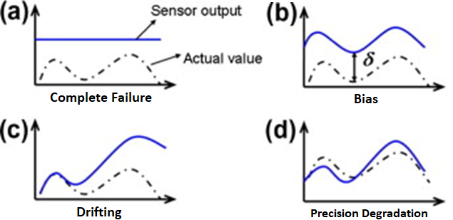

Figure 6. Four types of sensor inaccuracies to be considered in the framework

To study the quantitative impact of these fault types on FDD and building performance, quantification of severity is needed. The severity of each sensor fault type considered in this study is shown in Table 4.

Table 4. Parameters of sensor fault types to be considered in the case study

|  |  |  |
| --- | --- | --- |
| **Sensor Fault Type** | **Parameter Definition** | **Values** |
| Complete failure | Constant sensor reading | average of annual actual value |
| Bias | Absolute sensor value error | ±5% |
| Drifting | Sensor value change rate per year | ±5%/year |
| Precision Degradation | Random bias range | -5% to 5% |

After applying sensor inaccuracy, the inaccurate sensors are fed to FDD model to predict faults (a diagram of the process is shown in Figure 7). First, the four sensor fault types introduced earlier are applied to each sensor independently. For example, complete failure is applied to “fans_electricity [W]”, “gas_facility [W]”, etc. Similarly, sensor bias, drifting, and precision degradation are applied independently for all sensors and all building fault types, resulting in 4 sensor fault types * 20 sensor types = 80 analysis cases. Then we used the data from each case to build FDD models and execute fault detection and diagnosis for each building fault type (AHU Fan Motor Degradation, Duct Fouling, etc.).

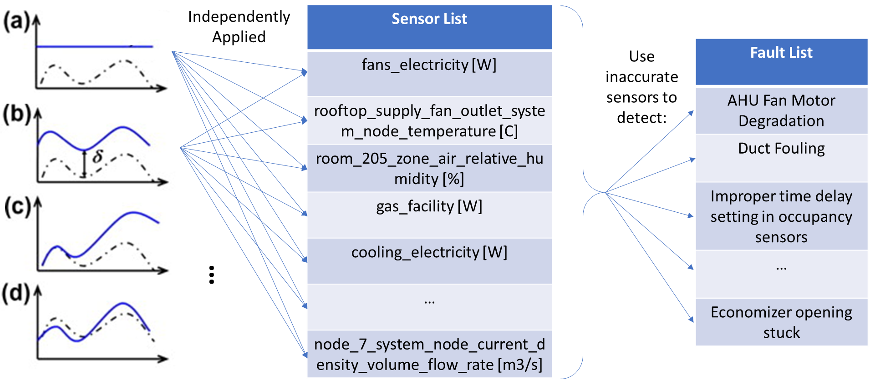

Figure 7. Diagram of applying sensor inaccuracy to sensors and the impact of inaccurate sensors on fault detection for different building fault types

It can be seen from Figure 7 that this analysis iterates over all sensor fault types, sensors, and building fault types, making it computationally expensive. However, it can provide us with a comprehensive evaluation of the impact of sensor inaccuracy on FDD and building performance. To complete this computationally expensive task, we utilized NREL’s supercomputer—Eagle.

With the results generated, a statistical analysis was conducted to help us answer the questions critical to this project: (1) does sensor inaccuracy have a large impact on FDD and building performance? (2) what sensor fault type is the most unfavorable in terms of deteriorating FDD performance? (3) what sensor(s) make FDD performance the most robust? The following tables summarize the answers to these questions.

Table 5. Aggregated results by sensor fault type

|  |  |
| --- | --- |
| **Sensor Fault Type** | **Model Accuracy Change** |
| Degradation | -4.7% |
| Failure | -16.4% |
| Shift | -1.8% |
| Drift | -3.8% |
| Average | -6.7% |

Table 6. Aggregated results by sensor type (top 10 and overall average)

|  |  |
| --- | --- |
| **Sensor with Inaccuracy** | **Model Accuracy Change** |
| fans_electricity [W] | -18.6% |
| rooftop_cooling_coil_outlet_system_node_temperature [C] | -11.5% |
| room_101_zone_mean_air_temperature [C] | -10.8% |
| 1f_plenum_zone_air_relative_humidity [%] | -10.2% |
| rooftop_supply_fan_outlet_system_node_temperature [C] | -9.5% |
| rooftop_heating_coil_outlet_system_node_temperature [C] | -9.5% |
| rooftop_supply_fan_fan_electricity_energy [W] | -8.4% |
| room_103_zone_air_relative_humidity [%] | -7.6% |
| room_105_zone_air_relative_humidity [%] | -6.9% |
| room_202_zone_air_relative_humidity [%] | -6.4% |
| Average for all sensors | -6.7% |

As can be seen from Table 5, sensor inaccuracy has a large impact on FDD performance, decreasing it by 6.7% on average. Because we only consider one sensor inaccuracy at one time, total impact would be larger when multiple sensors have simultaneous inaccuracy. Among the four sensor inaccuracies, complete failure has the most impact and sensor shifting has the least impact on FDD model performance, which is intuitive. These initial conclusions can inform sensor calibration and maintenance practices: we should focus on detecting complete sensor failure and precision degradation since they have the most impact on FDD performance.

As can be seen from Table 6, sensor inaccuracy in “fans_electricity [W]” decreases FDD performance by 18.6% on average; this makes sense because many economizer sensor faults are modeled in the FRP case study and fan electricity is a strong indicator of economizer operation. “rooftop_cooling_coil_outlet_system_node_temperature [C]” is also an important sensor for HVAC related fault types, and its inaccuracy will cause large decreases in FDD performance, especially for HVAC-related fault types. The 10 sensors for which inaccuracy has the largest impact on FDD performance are listed in Table 6, providing insight on the sensors to prioritize in the sensor calibration and maintenance process.

Specific conclusions are limited to this case study, meaning that the results are only truly applicable to the FRP. However, the FRP is a prototype small office building with a typical layout and HVAC design, such that it is reasonable to expect that the conclusions in this case study can be extended to other small office buildings in a general sense. A key aspect of future work is to study the extensibility of conclusions drawn for a typical building to other similar buildings.

## 3.2. Specifications on Domain 2: FDD Model Performance

In our previous work, we wrote a comprehensive report that summarizes FDD model performance metrics [11]. Although we used False Positive Rate (FPR) and Combined Detection and Diagnosis Rate (CDDR) to evaluate sensor selection and sensor accuracy for this case study, we list all potential FDD performance metrics in the following figures for completeness.

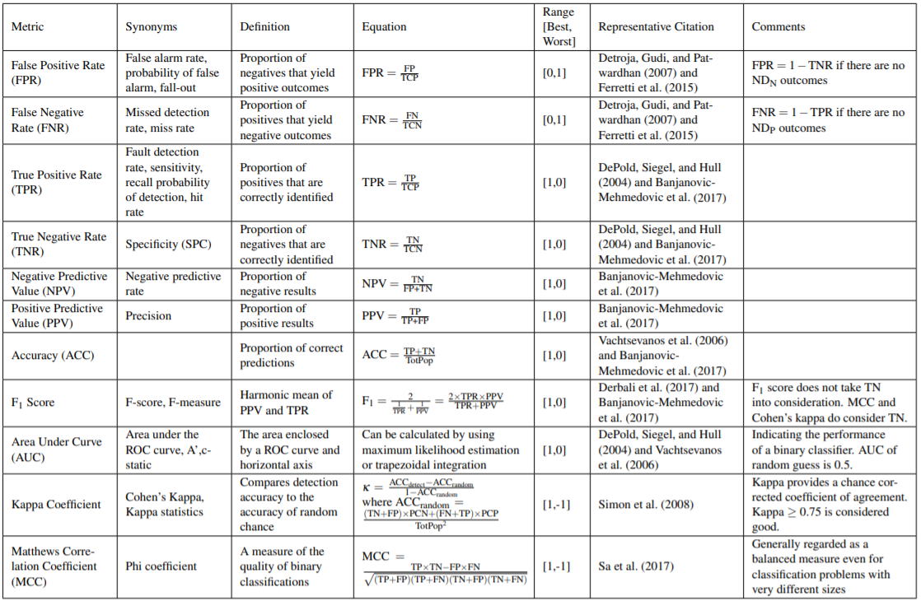

Figure 8. FDD performance metrics: Part 1. detection metrics ([11])

## 3.3. Specifications on Domain 3: Building Performance

Working with ORNL, we identified the key aspects of building performance to be considered when evaluating sensor impact from both a control perspective and a FDD perspective.

### 3.3.1. Summary of building performance metrics

Table 7 summarizes metrics used to evaluate sensor impact on building energy performance, occupant thermal comfort, and sensor cost. In addition, we have written two documents (<https://docs.google.com/document/d/11enMf8uqLk99luBHtiRvgBeuhuA6xEMXXQW-f9STa3Y/edit>, <https://docs.google.com/spreadsheets/d/1yMtqz8rzShePX_PN6ShUJJbYMUFOe_0CGCw69sCXOSQ/edit?usp=sharing>) that list costs related to sensors (e.g., installation, maintenance) and engineering efforts/investments (e.g., HVAC retrofit) required to realize the potential benefits of sensor information (e.g., energy saving).

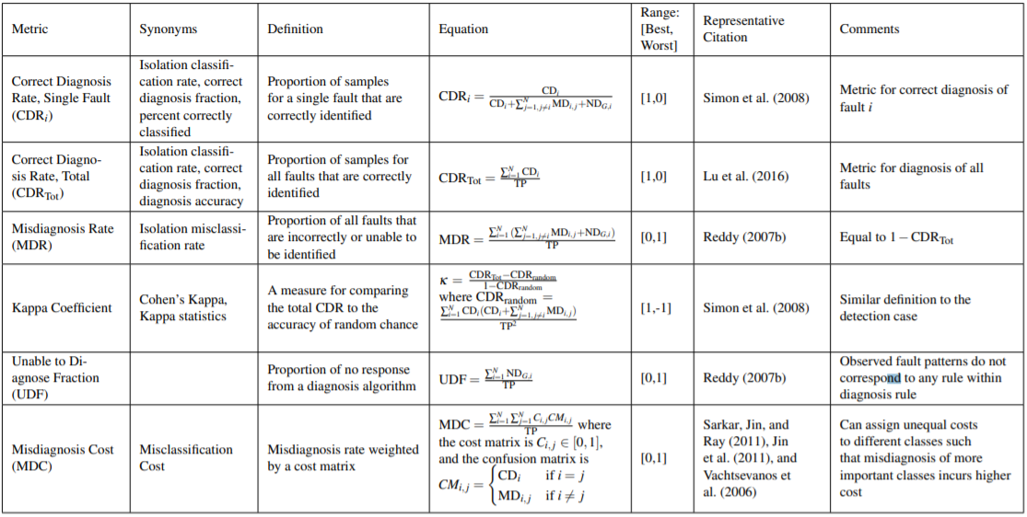

Figure 9. FDD performance metrics: Part 2. Diagnosis metrics ([11])

Table 7. Summary of building performance metrics

|  |  |  |
| --- | --- | --- |
| **Category** | **Subcategory** | **Metrics** |
| Energy Metrics | Metrics | Energy consumption |
| Energy cost |
| Peak |
| Global-warming potential |
| Energy sources | Electricity |
| Natural gas |
| Categories | Whole building |
| HVAC |
| Lighting |
| Time resolution | Annual |
| Seasonal |
| Monthly |
| Weekly or Daily |
| Thermal Comfort | Metrics | PMV |
| Spatial distribution | Space average |
| Sitting location |
| Temporal distribution | Unmet hours |
| Sensor Cost | Initial cost | |
| Operation cost | |
| Maintenance cost | |
| Others | Comprehensive/combined metrics | |
| Privacy (important especially for occupancy sensing) | |
| Level of intrusiveness | |

### 3.3.2. Quantification of sensor impact on building performance

We quantified sensor impact on FDD performance in Section 3.2. According to the developed framework, the next step is to further study its impact on building performance. In this case study, we selected annual electricity, natural gas, and net site energy as the energy metrics. We selected unmet hours during occupied cooling, unmet hours during occupied heating, and total unmet hours as the thermal comfort metrics. Sensor cost has not yet been analyzed for this case study; it will be addressed in FY21. Accordingly, a full analysis of sensor impact on building performance combining energy, thermal comfort, and cost metrics will be completed after FY 21 Q2, once sensor cost has been studied.

# 4. Summary and Future Work

In this report, Section 1 provided background on how sensor design and selection impact both FDD and building performance and described the need for a systematic and generic framework to evaluate sensor impact in this context.

Section 2 introduced our developed Sensor Impact Evaluation and Verification Framework for Fault Detection and Diagnostics. The framework consists of three domains (sensor configuration, FDD model performance, and building performance) and two evaluation modules (evaluating sensor impact on FDD and building performance, respectively). Each domain and evaluation module were described in detail.

Section 3 introduced the case study of applying part of the developed framework to Oak Ridge National Laboratory’s two-story Flexible Research Platform (FRP). In this case study, we:

* Studied Domain 1 (Sensor Configuration) for FRP via detailed sensor selection, sensor accuracy analysis, and quantification of FDD performance. We drew general conclusions on the impact of sensor selection and sensor accuracy on small commercial building performance.
* Summarized more detailed FDD performance metrics that can be applied to the FRP case. These FDD performance metrics are also applicable to other cases and can be included in the pool of FDD performance metrics available for future application of the framework.
* Summarized the detailed building performance metrics to be considered not only for the case study but also for the general framework.

Key next steps planned for FY21 include the following:

* **Summarize results of analysis exploring the impact of sensor accuracy on sensor selection for FDD**. In the current work, we study sensor selection and sensor accuracy independently. In the future, the interaction between sensor selection and sensor accuracy will be considered.
* **Document process for selecting and integrating alternative machine learning techniques into FDD evaluation and verification framework**. In the current work, we only consider random forest as the machine learning algorithm for FDD modeling. In the future, we will explore more machine learning algorithms and evaluate their compatibility with the framework.
* **Summarize results of sensor cost analysis**. As mentioned in Section 3.3, sensor cost is a critical factor in sensor selection. Currently sensor cost is only a conceptual component in the selected set of metrics; a more comprehensive sensor cost analysis is needed.
* **Develop plan to integrate control-focused findings and workflow(s) into FDD evaluation and verification framework**. We will work with ORNL and PNNL to integrate controls-related sensor impact work with our FDD-related component. For now, FDD and controls are studied independently. In the FDD part, we have only considered scenarios with the most common building controls (PID-based control). There are more advanced controls like model predictive control and reinforcement learning to be integrated into the FDD work.

# 5. References

1. Katipamula, S. and M.R. Brambley, *Methods for fault detection, diagnostics, and prognostics for building systems—a review, part I.* Hvac&R Research, 2005. **11**(1): p. 3-25.

2. Roth, K.W., et al., *Energy impact of commercial building controls and performance diagnostics: market characterization, energy impact of building faults and energy savings potential.* Prepared by TAIX LLC for the US Department of Energy. November. 412pp (Table 2–1), 2005.

3. Brambley, M.R., et al., *Advanced sensors and controls for building applications: Market assessment and potential R&D pathways*. 2005, EERE Publication and Product Library, Washington, DC (United States).

4. Frank, S., et al., *Hybrid model-based and data-driven fault detection and diagnostics for commercial buildings.* Proceedings of the 2016 ACEEE Summer Study on Energy Efficiency in Building, 2016: p. 12-1.

5. Chen, Y., L.J.E.C. Lan, and Management, *Fault detection, diagnosis and data recovery for a real building heating/cooling billing system.* 2010. **51**(5): p. 1015-1024.

6. Department_of_Energy, U.S. *EnergyPlus Energy Simulation Software, Version 8.1.* . 2013; Available from: <https://energyplus.net/>.

7. DOE, U.J.E.E. and R. Energy, *EnergyPlus, Energy Simulation Software, US Department of Energy.* 2009.

8. Goldwasser, D., et al., *Advances in Calibration of Building Energy Models to Time Series Data*. 2018, National Renewable Energy Lab.(NREL), Golden, CO (United States).

9. Im, P., M. Bhandari, and J. New, *Multi-Year Plan for Validation of EnergyPlus Multi-Zone HVAC System modeling using ORNL’s Flexible Research Platform*. 2016, Oak Ridge National Lab.(ORNL), Oak Ridge, TN (United States). Building Technologies Research and Integration Center (BTRIC).

10. Im, P., M. Bhandari, and J.J.O.R. New, TN, *Multi-Year Plan for Validation of EnergyPlus Multi-Zone HVAC System modeling using ORNL’s Flexible Research Platform.* 2016.

11. Frank, S.M., et al., *Metrics and Methods to Assess Building Fault Detection and Diagnosis Tools*. 2019, National Renewable Energy Lab.(NREL), Golden, CO (United States).